**Use Google and Whois for Reconnaisasance.**

Aim:

To find out the Whois, DNS Records and Diagonstics for particular website by using Whois search.

**Procedure:**

Step1: Open the WHO.is website

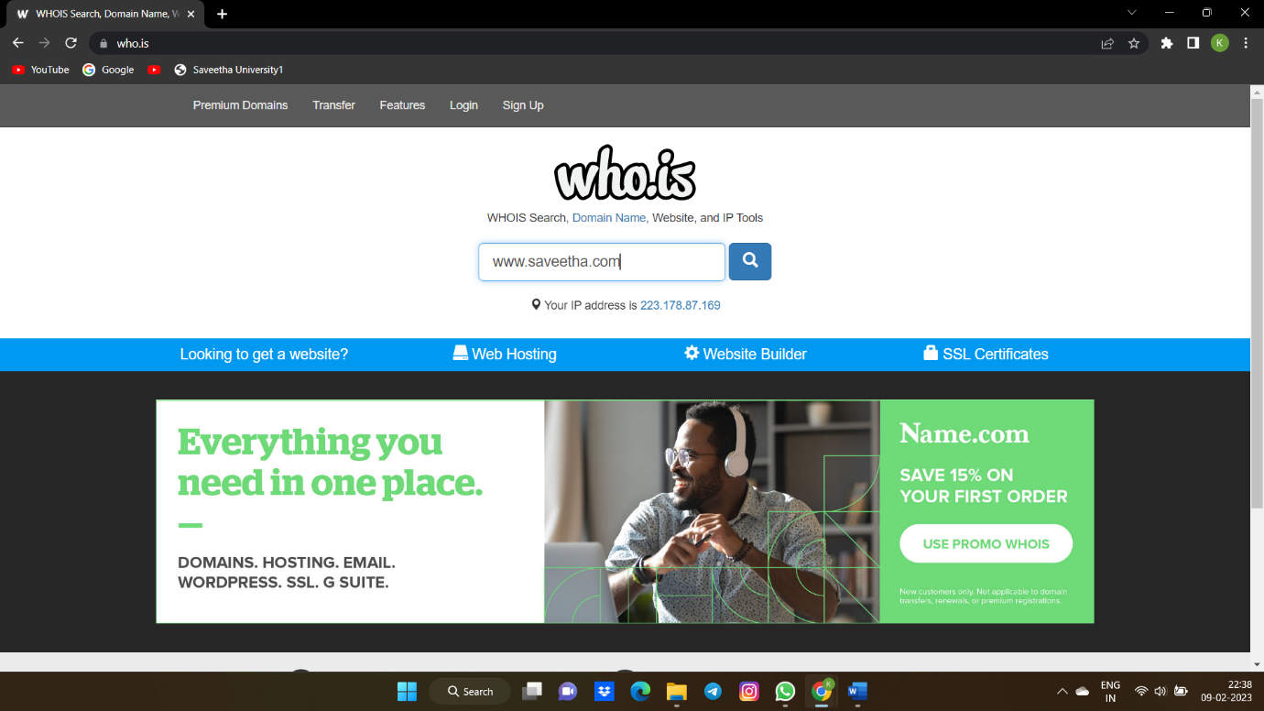

Step 2:

Enter the website name in search bar and hit the “Enter button”.

Step 3: Show you information about [www.saveetha.com](http://www.saveetha.com/)

OUTPUT:

1.WHOis

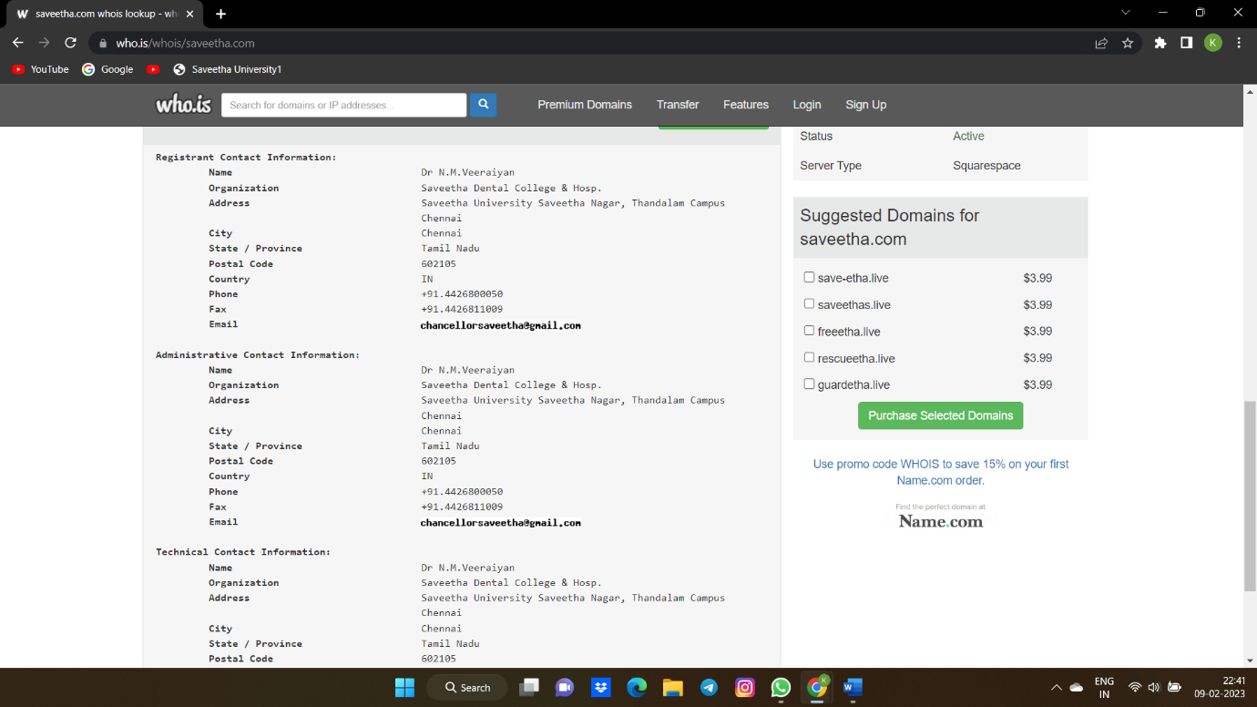

2.DNS

3.Diagonostics

**RESULT**:

Hence the WHOis DNS records and diagnotics for particular website by using WHOis search is performed susscessfully.